1.6 Work

Motivation:
Suppose an object moves in a straight line and a constant force F acts on the object in the direction in which the object moves.

In order to compute work done on the object we need the two following formulas:

- (, where
- (distance)

Note: We typically measure
- F in Newtons
- d in meters (m)
- W in joules (J) which is Newtons times meters (i.e., )

Note: When force is measured in pounds and distance is measure in feet, the unit for work is .

Note: In calculus III work is studied for a much more general (and some would argue much more useful) perspective with vectors.

The main question that will be answered in this section is: How do we calculate the amount of work done when the force acts on the object in the direction in which the object moves, but the force is NOT constant?

Exploration:
Suppose an object moves along a number line from a to b. Suppose that is a continuous function that represents the force acting on the object at any given point .

To approximate the force acting on the object we partition the interval into subintervals of length . Then, to approximate the force acting on the object in each subinterval we plug a sample point in each subinterval into our function: . The approximate work done in the subinterval is then . As a whole, the approximate work done is: , and we recognize this as a Riemann sum!

Definition: The work done in moving an object in a straight line from a to b is:

where f is defined just as it was in the exploration.

Example 1: A 200-lb cable is 100ft long and hangs vertically from the top of a tall building. How much work is required to lift the cable to the top of the building?

As illustrated below, suppose we partition the cable into n “pieces” of length . We notice that the weight of the cable is . Below are two different possible setups.
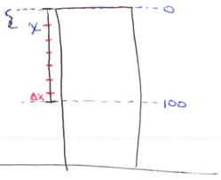  For a single cross section of cable we know that:  and we approximate the distance by taking a sample point in the interval and so  Therefore the work done on a piece of cable is given by:  Thus the total work done is approximately.  To get the exact work done, we let the number of pieces of cable approach infinity, and we get: . | 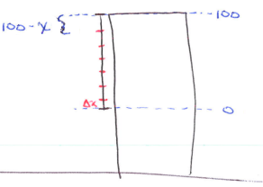  For a single cross section of cable we know that:  and we approximate the distance by taking a sample point in the interval and so  Therefore the work done on a piece of cable is given by:  Thus the total work done is approximately.  To get the exact work done, we let the number of pieces of cable approach infinity, and we get:

Question: What if a 500lb trough of water is attached to the end of the cable and is also being lifted?
Setup:
We can use the previous integral for measuring the work required to pull up the chain and add the work required to pull up the new item. Since the force acting on the bucket is constant the work required to move it is easy to calculate.

The new item is 500lbs and needs to be pulled a distance of 100ft. So, . Therefore we have:
Evaluate:
Example 2: A 10ft chain weighs 25lbs and hangs from a ceiling. Find the work done in lifting the lower end of the chain to the ceiling so that it’s level with the upper end.

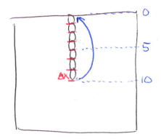
As illustrated below, suppose we partition the chain into n “pieces” of length . We notice that the weight of the chain is .

For a single cross section of chain we know that:
and we approximate the distance the chain needs to move by taking a sample point in the interval and so

Therefore the work done on a piece of chain is given by:

Thus the total work done is approximately.

To get the exact work done, we let the number of pieces of chain approach infinity, and we get: .

Example 3: A rectangular tank 2m long, 3m wide, and 1m deep is full of oil that has a density of . Find the work required to pump all of the oil out over the top side of the tank.

Suppose we partition the oil in the tank into n “slices” of thickness .

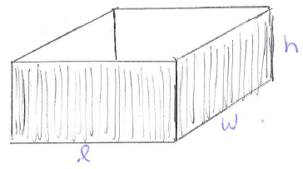
Setup:
$$2 m$$
$$3 m$$
$$1 m$$
For a single cross section of the tank we know that:

Therefore the work done on a slice of oil is given by:
Thus the total work done is approximately.
To get the exact work done, we let the number of slices of oil approach infinity, and we get: .

Example 4: A tank has the shape of an inverted circular cone with height 10ft and base radius 4ft. It is filled with water to a height of 8ft. Find the work required to empty the tank by pumping all of the water to the top of the tank. (The density of the water is )

Suppose we partition the water in the tank into n “slices” of thickness .

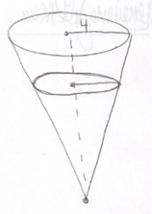
Setup:
$$10 ft$$
$$2 ft$$
$$8 ft$$
By similar triangles we know that .
So for a single cross section of the tank we know that:

Therefore the work done on a slice of water is given by:

Thus the total work done is approximately.
To get the exact work done, we let the number of slices of oil approach infinity, and we get:

